
NOTICE
Subject: Talent Hunt Event - Registration Invitation.
This is to inform all students of the institution that a Talent Hunt Event is being organised in the institution to showcase and celebrate your unique skills and abilities. We are excited to provide a platform for you to highlight your talents in various fields such as performing arts, sports, innovation, music, literature, and more. Prizes and Certificates will be provided.
How to Register:
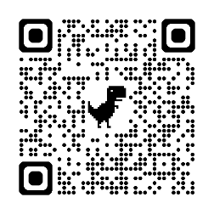
- Fill out the details in the provided Google Form using the link below: https://forms.gle/28bZyJTNndUwgPLD8, or scan the QR code

- After submitting the form, kindly contact your respective Head of Department (HOD) or In-Charge or Ms. Tooba Shah, Foreman Engr/Incharge Workshop for further guidance, approval, and coordination.
This is a golden opportunity to express yourself and contribute to the vibrant culture of our institution. We encourage all talented students to participate actively.

Let's unleash your potential!

No: KGP/Estt/2025/1409
Dated:18-10-2025

Principal
Kashmir Government Polytechnic College
Srinagar

Copy to the:
1.All Concerned for Compliance.

